03 - Lesson 3 – HTML & CSS

Before you begin
I have re-organised the folder names on your web host to lesson-01, lesson-02 and lesson-03, this Organisation of files and folders will help keep things simple and organised.

The HTML5 standard template
This is the HTML5 standard template / basic structure:

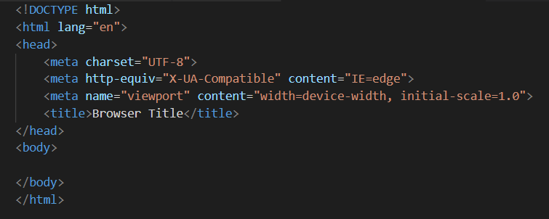
You can get away with just:

hello world

saved to a file called test.html and it would work, but the above is the standard HTML5 template.

Remember from lesson 1 this is the bare html template:

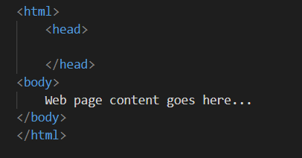

This is fine, but it’s not 100% correct for the HTML 5 standard, the structure has varied between version: HTML 1, to HTML 4, DHTML, XHTML and now HTML5. But not by much.

HTML5 – The basic template & VS Code
This is the HTML5 basic template, if your creating a HTML5 page, this is what you should be starting with.

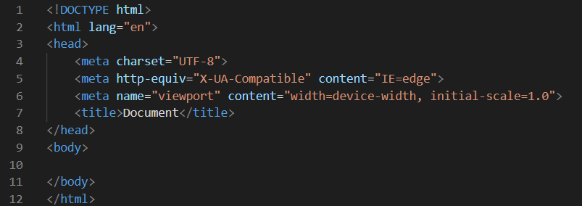
So now create a folder in your lessons folder called lesson-03 and right click in this folder (in a blank space where files would appear) and choose open with VSCode (this is how it works on a PC, not sure on a mac).

VSCode should then open locked into that folder, e.g.: This is often displayed as the welcome screen, feel free to close that via the tabs top of the right (main) work area.

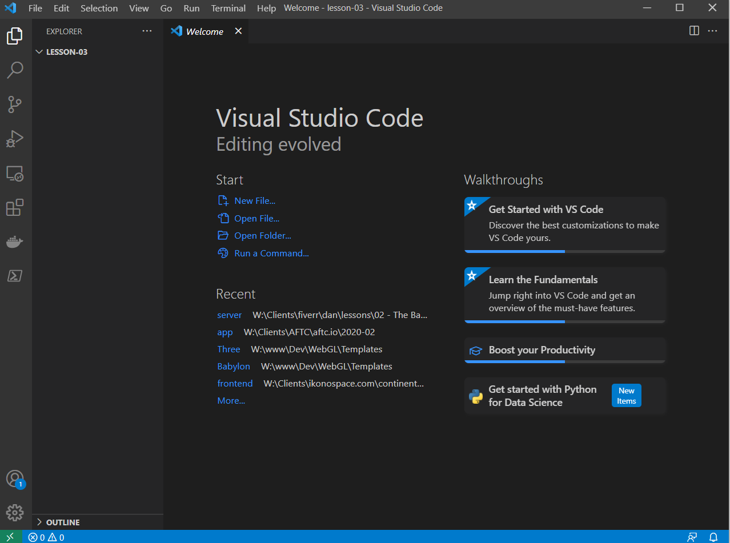
You will notice on the left (the file explorer pane), that its got LESSON-03 at the top, showing that VSCode is working in that folder.

Now right click under lesson-03 and in the popup menu create a new file called test.html and you should see this:

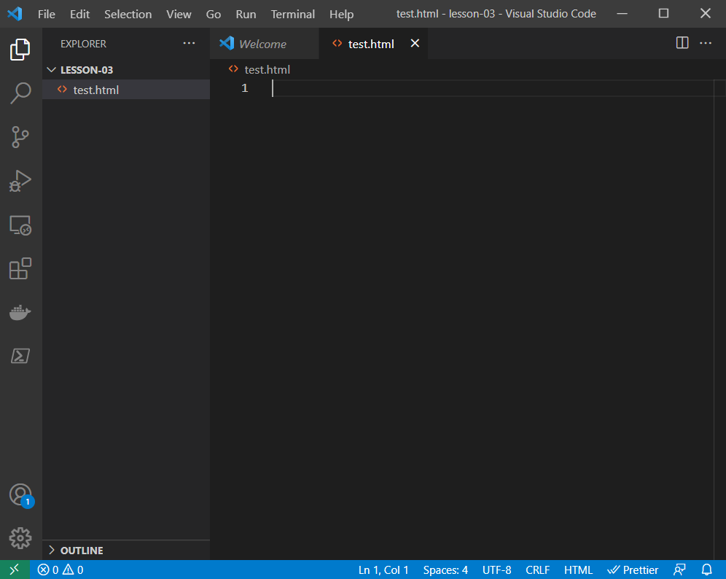

VSCode uses tabs at the top, as you can see, Welcome is still open, hover your mouse over this and click the X (close) button to get rid of it.

Now in the text.html tab, at the top type html this should give you intellisense options for code hints and template injection options via a popup automatically, to force it to give you these options you press CTRL and SPACE or I think it’s OPTION and SPACE on a mac (not sure). You will now see 3 options e.g.:

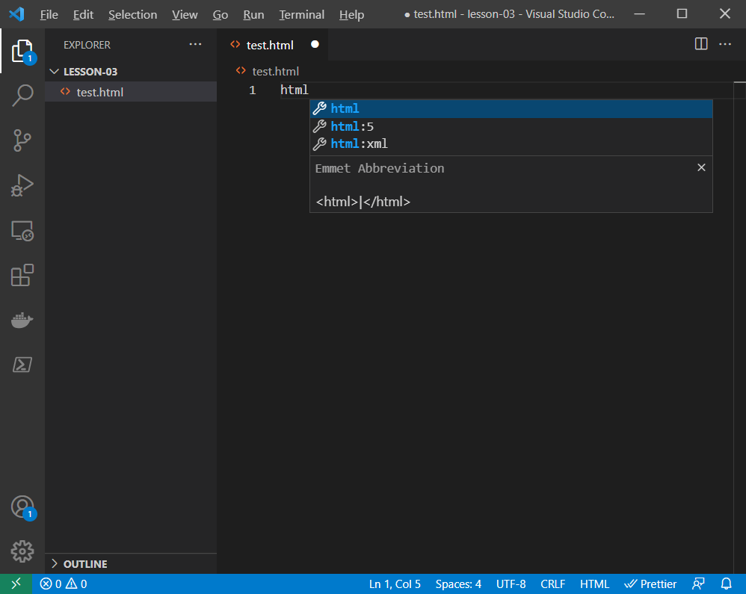
Using the arrow keys and enter to select or the mouse, select html:5 and press enter. I pref’ to use the arrow keys. Once you have done this you should see:

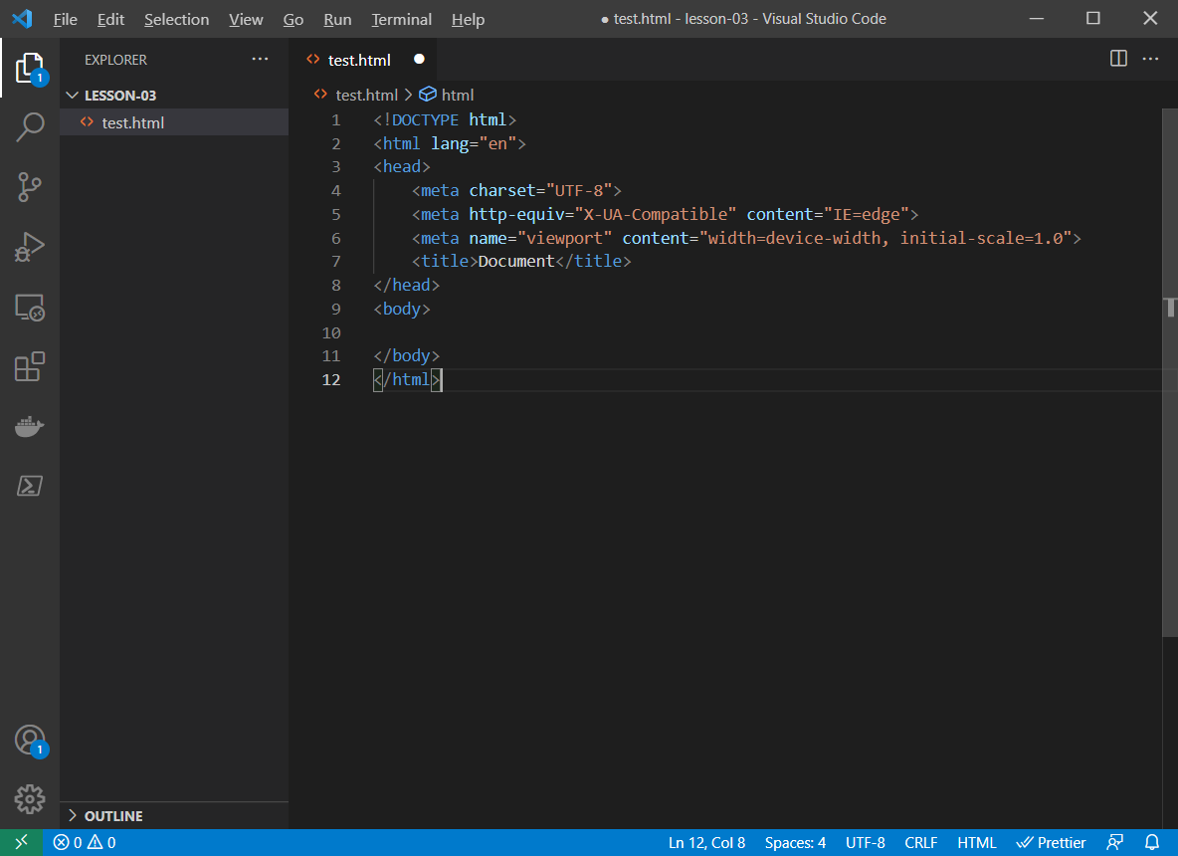
And your HTML5 template has been generated for you. This is how you should start all your pages.

When working on larger HTML projects I create a single page template first, with no content, then customise that page and then replicate it many times for content insertion. This would most often be for a header, navigation, content and footer sections.

HTML – Attributes
The HTML5 base template has many attributes:

What is an attribute?

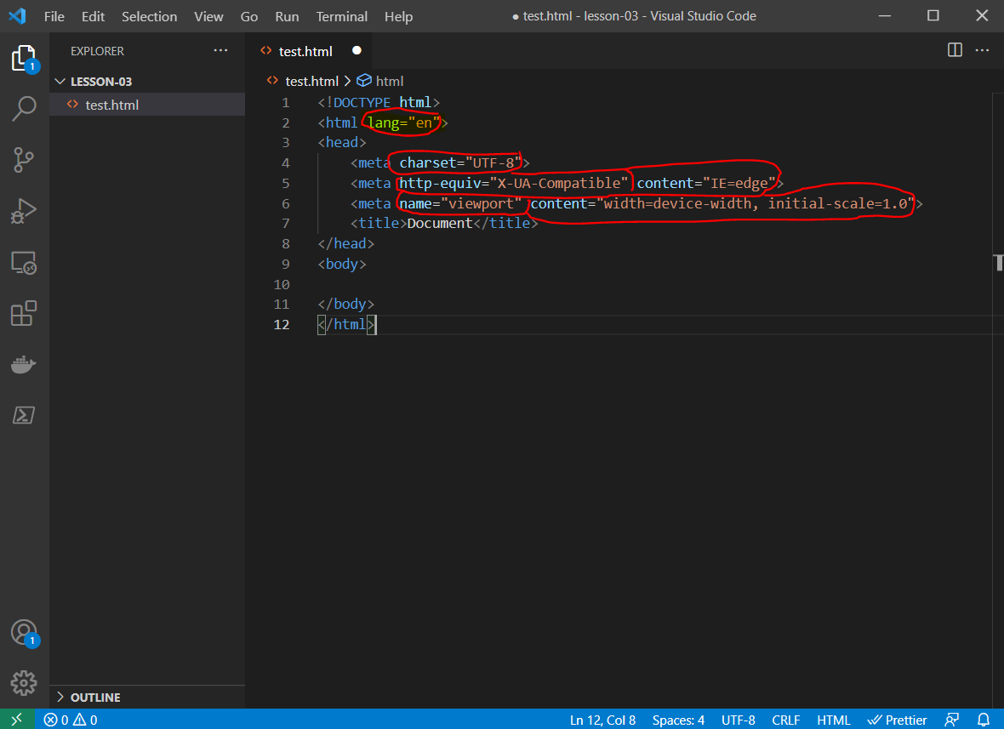
Everything circled in red is an attribute.

Lang=”en” is an attribute of the HTML opening tag
charset=”UTF-8” is an attribute of the meta tag

Tags are HTML, HEAD, META, BODY, P, B, DIV, SPAN, etc… There are a lot of them, see https://www.w3schools.com/TAGS/default.ASP . No need to remember them all.
Learning resource
Since 1999 I’ve been referring to the w3schools website for lookup of code snippets or information that I’ve forgotten or checking on updates. I suggest you use it and keep it as a bookmark in your web browser.

How not to write html (Lesson 2 – the default page you created)

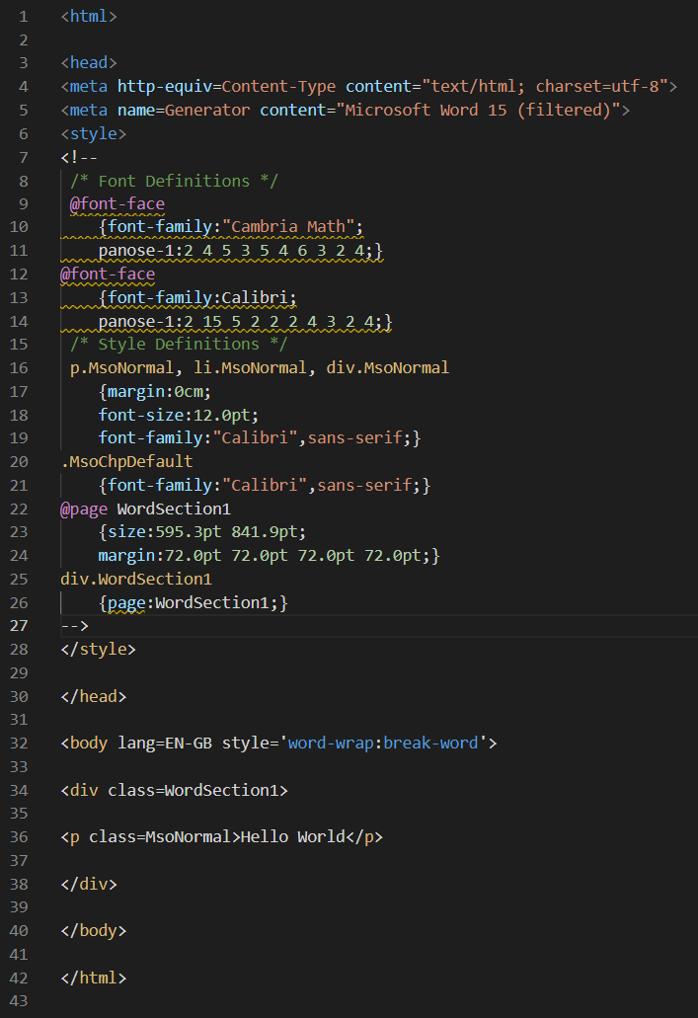

This is a generated MS Word or some other tool’s jumble of html and css, as you can see far from clean and not really correct.

An attribute is always set via age=”my value” never lang=EN-GB.
You can use an apostrophe ‘ or quotes “ for encapsulation of html attribute values, encapsulation examples:

<p class=”bob”>hello bob</p>
<p class=’bob’>hello bob</p>

Never use ` or the special character quotation marks which can look like a 66 or 99 (which some websites will do auto conversion to or something like word may copy and paste as).
For me it’s either SHIFT & 2 (key for the “ symbol) or just the ‘ symbol which is my @ key also when I use shift. Might be different on a mac.

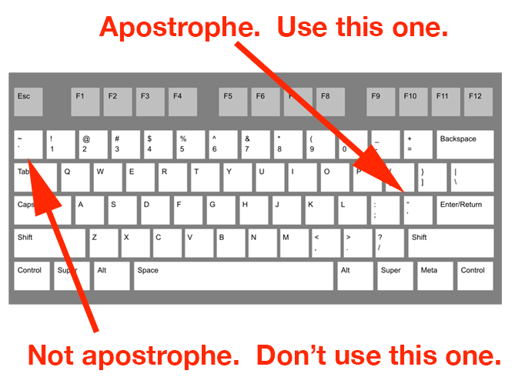
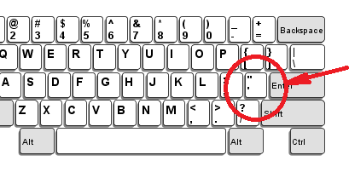

This is where the “ is on the US layout keyboards and often MAC (UK below).

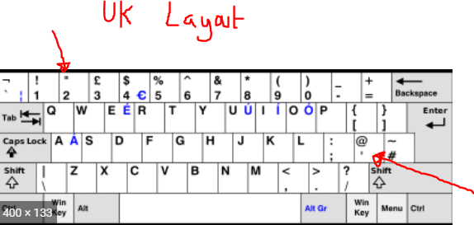

So I would always be using:
shift & 2 for “
or ‘ (2 keys right of the L key).

Never mix and match quote types: e.g.
name=”darcey’
or
name=’darcey”

The Browser Title
Not sure how relevant this will be in ePub but for HTML websites to name the browser title is very important.

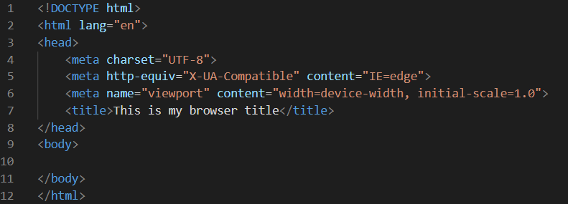
On line 7 you will see the title tag, note there is a little trick of formatting going on here and many programs do this.

The HTML tag is the root tag, the HEAD tag is an inner tag of the HTML tag, and the title tag is contained within the HEAD tag.

Much like how you work with P and B tags.
<p>hello <b>world</b></p>

Everything in the above piece of html is contained in a P tag, the word world is encapsulated/enclosed/contained within a B tag which is inside the P tag.
HTML Language tag

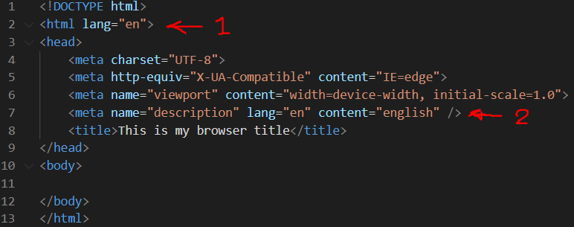

Most websites work with languages by placing the lang attribute on the HTML tag (no 1), but you can place the lang attribute on any tag, but this is for the browser or search engines to display the most appropriate language.

The older way of doing this is via a meta tag (not sure which will be best for epub, or even if it’s supported).

I typically use no 1 and let the browser work out what language it is from that.
HTML SETTING THE CHARACTER SET
It is always best practice to set the character set to UTF-8 this character encoding set can handle special characters and symbols, but WARNING: The font you use may not be able to handle them.

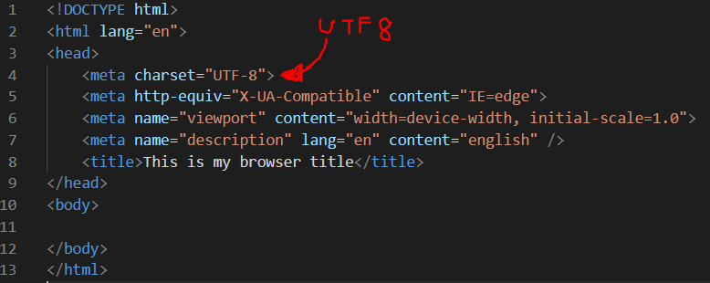

HTML VIEWPORT
This can be used for many things but is most commonly used to limit mobile & tablet devices to prevent zoom, or set limits, this is a big subject, this is where your google kung fu skills should start to be used.

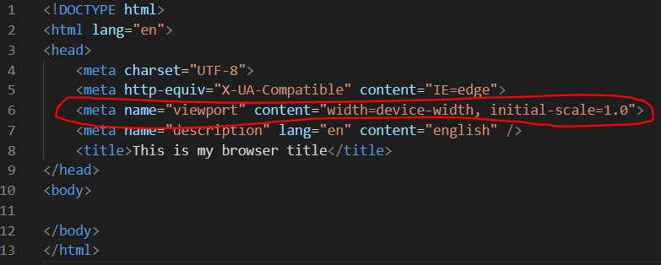

HTML & CSS
There are 3 methods of embedding CSS in your HTML pages:

1. Linking to CSS files (the proffered option)
2. Embedded CSS (writing CSS directly into your HTML files)
3. Inline CSS

Embedded CSS
Embedding CSS directly into your HTML files is the quick and dirty option, things can get messy fast but is often very useful for quick fixes, as soon as you get past 10 lines of CSS code you should be really thinking about moving your CSS to a separate file.

Embedded CSS example:

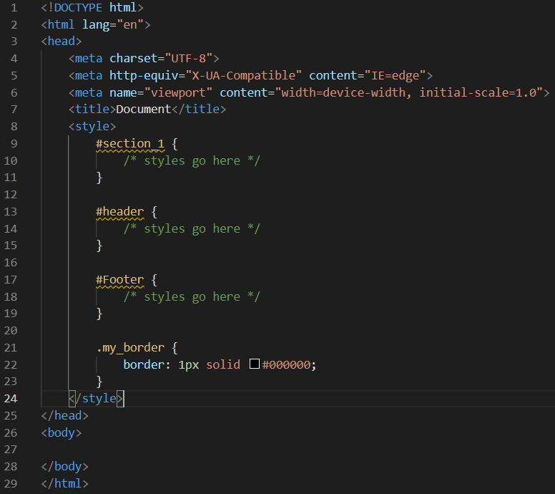

Inlines CSS example

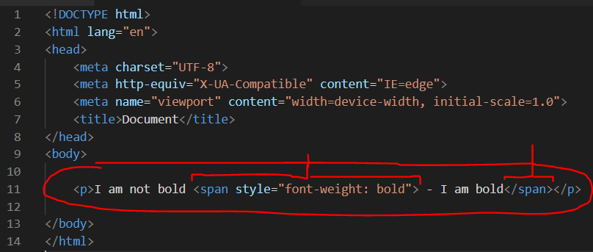
Line 11 is an inline CSS example, this is typically only used when you’re creating HTML emails these days but many javascript libraries will manipulate css and you will see these all through your HTML after they have been adjusted.

If you try the above code you will notice that the span tag doesn’t cause a line break or new line to occur, this makes the span tag a very useful html tag to use at times.

CSS ID’s vs Class’s
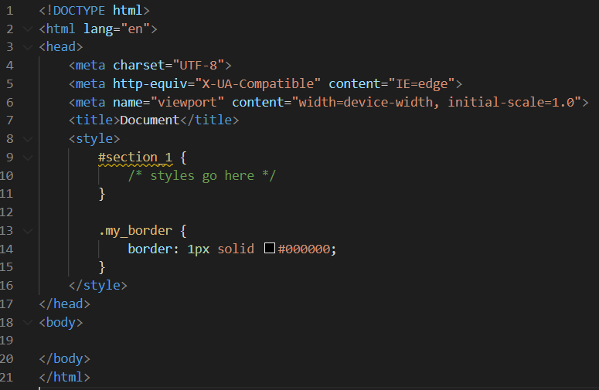
The rules is:

1. If there is only ever going to be 1 HTML element that you need to adjust with CSS or JavaScript then that should be given an ID. ID#s always start with a #

2. If you wish to adjust many HTML elements and replicate a CSS style to many of them, you use a class. Class’s always start with a .

Naming best practices
- Never use spaces
- Try to use _ instead of – (The exact opposite of file names)

There are reserved words in CSS which cannot be used, so if you sometimes get a HTML element that wont style, try changing the ID or Class name that is applied to that tag.
Nested CSS Tags

Much like HTML CSS tags can be nested this is common, E.G.:

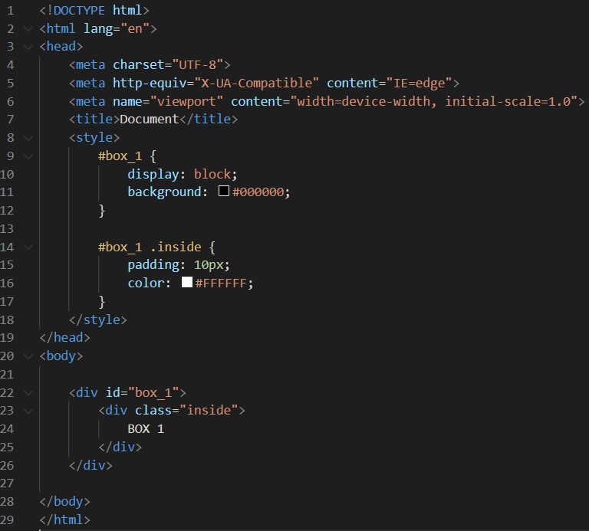
There is a HTML DIV element, with an ID of box_1 and has a class inside it called inside

NOTE:
No # or . for CSS when using them in HTML.

An ID in HTML is

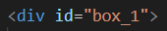

A CSS Class in HTML is

Lesson 3 - Tests
There is quite a lot above to go through, so this lesson’s tests will be short.

Lesson 3 Test 1
In your server space in the Lesson 3 folder, create 3 HTML pages (test-1.html to test-3.html), for each you will need to:
- Each page must be the standard HTML5 template
- Title the web browser Lesson 3 Test 1 to 3 appropriately
- In each page create a box much like the example above, test-1.html must be a yellow box, test-2.html must be a green box and test-3.html must be a white box with black text.

REMEMBER
All the information you need to complete the tests above, you have the all the information you need above. If you get stuck, google first then ask me (you got to get your google skills up).

Lesson 3 Test 2 – The challenge

- Create another html page (appropriately named – hint in Test 1)
- Create all the boxes from Test 1, all must be the same colours and text colour, but this time on a single page. However all the boxes must have a gap between them.

HINT: margin: 50px;
Try it out, see where it works, what it does and how to use it.

Once you have finished the above, please let me know on fiverr and I will review.

